Why Fundraise? A Word about the 2022 Port Perry Dragon Boat Festival Charitable Program.
The Port Perry Dragon Boat Festival provides vital support for the Port Perry Hospital Foundation and Scugog Lake Stewards. After a 2-year hiatus of the event and its fundraising impact due to COVID-19, this year we are depending on you more than ever!


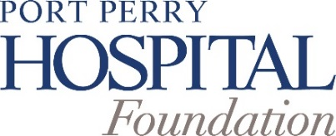
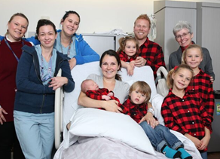
Funds raised through past Port Perry Dragon Boat Festivals have supported medical equipment in the New Life Centre, Emergency, and Surgery Departments, as well as a hospital-wide update to IV Smart Pump technology.
This year, funds raised through the Festival will continue to support priority medical equipment and other enhancements to patient care across the hospital.
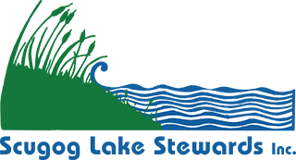
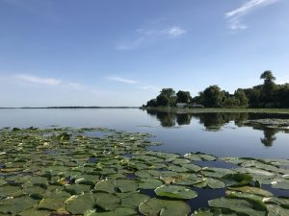
The Scugog Lake Stewards are committed to protecting and improving Lake Scugog. With their partners, the Township of Scugog and Kawartha Conservation, they are currently working on the Lake Scugog Enhancement Project, to help clean storm water running off urban land into Lake Scugog and to upgrade boating and angling opportunities in parts of Port Perry Bay.
Your support will help improve the quality of the lake for not only the plants and animals that call it home, but also for all our beautiful lake has to offer now and for generations to come.

Funds raised at the Festival are shared 80% to the PPH Foundation & 20% to Scugog Lake Stewards.
To maximize your fundraising efforts, create an online team and individual fundraising pages and ask friends and family to support you. Visit www.pphfoundation.ca/community-events/port-perry-dragon-boat-festival-2022/ to get started. *Print Pledge Form is also available.
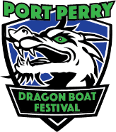
Great prizes will be awarded for Top Individual Fundraising. Check Port Perry Hospital Foundation’s Dragon Boat Festival link at http://www.pphfoundation.ca as prizing information is made available.
And as far as bragging rights are concerned, after a two year hiatus of the Festival due to COVID-19, once more the festival’s Top Fundraising Team will have their Team Name added to the Port Perry Dragon Boat Festival Paddle.
WHEN YOU FUNDRAISE, WE ALL WIN!
Learn more about these charities at pphfoundation.ca and scugoglakestewards.com

